Fatigue Monitoring in Advanced Manufacturing and Supply Chain (AMSC) Using Wearable Technology
Emily Montgomery
Industrial Engineering Department
University of Louisville Louisville, KY, USA
edmont02@louisville.edu
Advisor: Dr. Yunmei Liu
Industrial Engineering Department
University of Louisville Louisville, KY, USA
yunmei.liu@louisville.edu

Abstract--In Advanced Manufacturing and Supply Chain (AMSC) environments, workers frequently face demanding conditions that contribute to physical strain and increased fatigue, impacting safety, productivity, and well-being. The goal of this study is to investigate and develop effective methods using wearable electromyography (EMG) sensors to monitor and predict muscle fatigue in workers performing repetitive forearm tasks within AMSC settings. The flexor digitorum superficialis (FDS) and extensor digitorum communis (EDC) forearm muscles, vital for gripping and grasping activities, were the focal points. Signal processing techniques included Fast Fourier Transform (FFT), Power Spectral Density (PSD), and various time-domain metrics and analyses (raw EMG, filtered EMG, rectified EMG, EMG envelope, SD, MAV, RMS). FFT analysis identified fatigue in FDS trials 4 and 5, prompting further exploration of frequency domain indicators over time-domain counterparts. Trials utilized the Delsys Trigno Lite System Surface EMG Sensors and Camry Electronic Hand Dynamometer. Baseline data was collected from the dominant arm performing fatigue-inducing activities interspersed with rest periods. In this study I identified key metrics for fatigue assessment. A Python program was developed to visualize, process, and extract features from EMG and accelerometer data, including root mean square (RMS) and median frequency (MDF) plots. Future research aims to refine these findings with larger participant pools and varied tasks, integrating identified metrics into machine learning and deep learning models for predicting muscle fatigue.
Keywords—muscle fatigue, Advanced Manufacturing and Supply Chain (AMSC), signal processing, surface electromyography (sEMG)

INTRODUCTION
In Advanced Manufacturing and Supply Chain (AMSC) environments, workers frequently perform repetitive tasks with their hands, leading to musculoskeletal issues and increased fatigue [1][2][20]. This fatigue can significantly impact worker productivity, safety, and overall well-being.
Therefore, monitoring and predicting muscle fatigue is crucial for creating safer and more effective working conditions. Fatigue monitoring can help identify early signs of overexertion, allowing for timely interventions to prevent injuries and reduce downtime [1][2][20].
Implementing wearable EMG sensors and other advanced monitoring technologies can provide real-time data on muscle activity, offering valuable insights into worker fatigue levels [1][2][20]. These technologies can be integrated into ergonomic programs to further improve workplace safety and health outcomes.
This is why effective fatigue monitoring in AMSC environments not only protects workers’ health but also contributes to the overall efficiency and sustainability of manufacturing operations [20].
Electromyography (EMG) is a technique used to record muscle activity by detecting the electrical signals generated when motor neurons transmit instructions from the brain to the muscles [3]. In this study, we utilize surface EMG (sEMG) sensors, specifically the Delsys Trigno Lite System, which are non-invasive and easy to use. These sensors capture the electrical activity of the muscles, providing raw EMG signals that can be visualized and analyzed to detect muscle fatigue [4].
The flexor digitorum superficialis (FDS) and extensor digitorum communis (EDC) muscles in the forearm were chosen as the focal points of this study. Other forearm muscles considered included the extensor carpi radialis longus, flexor carpi radialis, pronator quadratus, and pronator teres. The FDS and EDC muscles were selected because they are accessible for surface EMG use, minimizing crosstalk from neighboring signals [5]. Additionally, these muscles are complementary – FDS flexes the digits, while EDC extends them – and are essential for gripping and grasping activities commonly performed in AMSC environments [6][7].
Various signal processing techniques were applied to the EMG data collected from the FDS and EDC muscles. These techniques included:
- Filtering the EMG signal with a 4th order Butterworth bandpass (20-450Hz) [12][15] [Figures 4 and 5]
- Rectifying the EMG signal [12][Figures 2 and 3]
- Generating EMG envelopes with a low pass filter of 10Hz [12][Figures 2 and 3]
- Calculating RMS, MAV, and SD for each trial [13][Tables 1 and 2]
- Plotting accelerometer data along its three axes (x, y, z) and calculating its magnitude [8]
- Applying Fast Fourier Transform (FFT) and Power Spectral Density (PSD) for frequency domain analysis [12][16][17][Figures 6 and 7]
- Comparing results with 500 ms moving windows for RMS and MDF plots [14][19][Figures 8 and 9]
Filtering is crucial to focus on relevant frequencies and minimize noise contamination. Time-domain and frequency-domain analyses offer different insights, and plotting both provides a comprehensive view of the data. Accelerometer data helps understand movement changes associated with fatigue, such as hand tremors [8].
Initial findings indicate that frequency domain analysis, particularly FFT, revealed signs of fatigue in FDS trials 4 and 5. In contrast, as shown in “Figures and Tables” section, time-domain metrics and PSD plots showed little to no change between fatigue-free and fatigued trials. Typically, fatigue would result in increased RMS and decreased MDF, but our data showed a more pronounced response in the frequency domain.
To collect EMG and accelerometer data, the Camry Electronic Hand Dynamometer was used by squeezing and releasing it over specified periods. Trials consisted of 20 minutes rest, followed by 1.5 minutes of fatigue-free activity and 1.5 minutes of fatigued activity, repeated a total of five times. Data was collected from the dominant arm.
My role in this study involved collecting EMG and accelerometer data, processing the data through signal processing and feature extraction methods, and identifying valuable features for further study. I developed a Python program for EMG signal processing, feature extraction, and data visualization. These features were shared with my team for application in machine learning algorithms to predict muscle fatigue.

METHODOLOGY

Participants
Due to time constraints, we were unable to get IRB approved and conduct an experiment with a larger participant pool as initially planned. Instead, we collected baseline data to identify valuable features. Our experimental protocol aimed to include several tasks for participants to induce fatigue, with the goal of involving a large participant pool.
Initially, baseline data was collected on a 26-year-old adult female with no history of musculoskeletal disorders. The participant was right-handed and free from any upper limb injuries. This preliminary data collection helped establish a baseline for identifying useful feature extraction methods for the experiment.

Equipment and Materials
We used the Delsys Trigno System, which includes wireless sEMG sensors, a USB connector, and the Trigno Discover software application. The sensors were placed on prepped skin (cleaned with an alcohol wipe) using adhesive tape. Correct muscle placement was verified through preliminary tests. This system was chosen for its ease of use and non-invasiveness, and it was used to collect both EMG and accelerometer data [9].
Figure 1: Data Collection
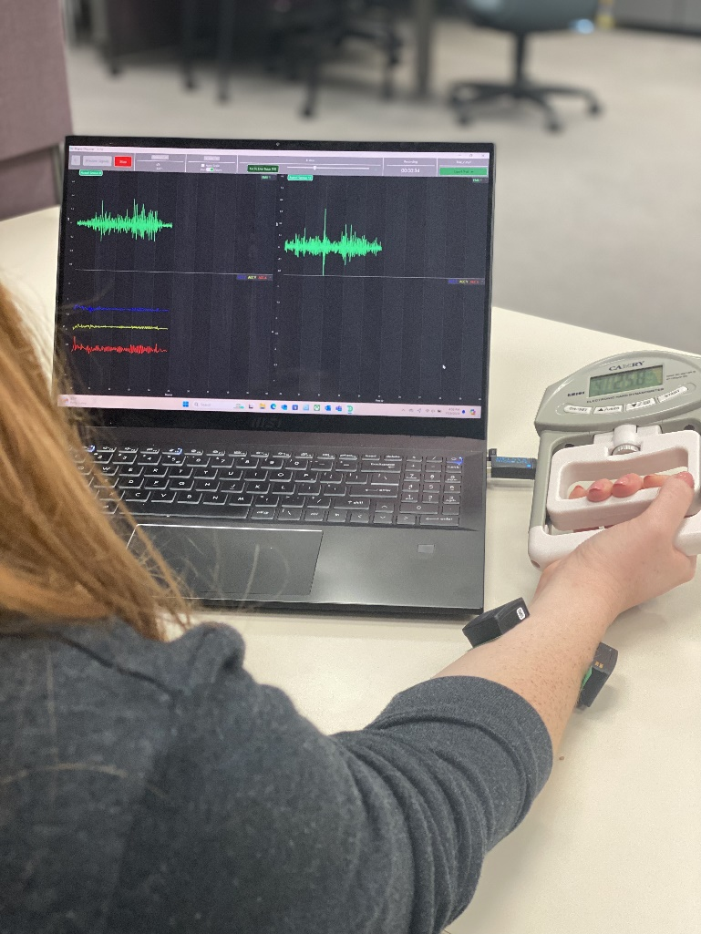
The Camry Electronic Hand Dynamometer was used as a controlled method of fatigue induction. The device can be set to different resistance levels, providing a measurable and repeatable task for participants. It records the force exerted, which decreases as muscle fatigue sets in. The participant was required to perform a series of grip and release actions until the trial ended.
Data was collected using the Trigno Discover software application, which allowed real-time visualization of the signals [10]. Data was saved as CSV files and later converted into Excel Files for processing.

Experimental Procedure
Correct placement of the Delsys sensors was crucial to ensure accurate data collection. This process involved the following steps:
- Preparation: The skin at the sensor placement site was cleaned with an alcohol wipe to remove any oil and dead skin cells, ensuring a good electrical connection [11].
- Reference Muscle Placement Guides: The Delsys EMG Sensor Placement Guide was used to determine the exact location for sensor placement. The guide provides detailed instructions on locating the muscle belly and ensuring the sensor is positioned over the muscle fibers rather than tendons or motor points to minimize crosstalk and noise contamination [11].
- Verification of Muscle Activation: To ensure proper placement, the targeted muscle’s activation was verified. For instance, for the flexor digitorum superficialis, the sensor was placed slightly below the wrist. Muscle activation was confirmed by flexing the fingers and feeling for the muscle’s contraction under the skin [11].
- Sensor Placement: Sensors were placed parallel to the muscle fibers to capture the best signal. According to the guide, sensors should be placed between a motor point and the tendon insertion or between two motor points [11]. It was essential to avoid the muscle’s edges and ensure the arrow on the sensor was aligned parallel to the muscle fibers [11].
- Application: After identifying the correct placement, the sensor was attached to the skin using an adhesive tape backing. The sensor was pressed firmly to ensure it bonded well to the skin [11].
The task involved using the Camry Hand Dynamometer. Participants squeezed the dynamometer for a few seconds, followed by a release period of the same duration, repeated until the end of the trial (1.5 minutes each for fatigue-free and fatigued conditions). The participant was encouraged to exert maximum effort throughout the trial.
Data was collected wirelessly through the Delsys Trigno Lite System and visualized using the Trigno Discover software. The software provides real-time data visualization, ensuring accurate data capture [10]. Data was saved in CSV format and converted to Excel for further processing in Python.

Data Processing
The collected EMG data was subjected to various signal processing techniques to identify relevant features indicating muscle fatigue. The steps included:
- Filtering: A 4th order Butterworth bandpass filter with cut-off frequencies between 20 and 450 Hz was applied to remove noise and irrelevant frequencies [12][15].
- Rectification: The filtered EMG signal [Figures 4 and 5] was rectified by taking the absolute value of each data point, ensuring all values were positive [12].
- EMG Envelope Generation: A low pass filter with a cut-off frequency of 10 Hz was applied to the rectified signal to create the EMG envelope [12][Figures 2 and 3].
- Feature Calculation: RMS, MAV, and SD were calculated for each trial to assess the overall signal amplitude and variability [13][Tables 1 and 2].
- Accelerometer Data Analysis: The x, y, and z components of the accelerometer data were plotted, and the magnitude was calculated as √(x² + y² + z²). Changes in movement patterns were analyzed to detect signs of fatigue, such as tremors [8].
- Frequency Domain Analysis: FFT and PSD were applied to the EMG signal to identify frequency domain indicators of fatigue [12][16][17]. Results were compared across trials to detect shifts in frequency content [Figures 6 and 7].
- Windowed Analysis: A 500 ms moving window was used to calculate RMS and MDF, providing a time-varying view of the features [14][19][Figures 8 and 9].
Python programming was used for data processing and visualization. The program was developed to automate these steps and generate plots for easy comparison of fatigue-free and fatigued conditions. The processed data provided insights into the effectiveness of the different metrics and methods used.

RESULTS
Initial findings showed that frequency domain analysis, particularly FFT, revealed clear signs of fatigue in FDS trials 4 and 5. In contrast, time-domain metrics and PSD plots showed little to no change between fatigue-free and fatigued trials. Typically, fatigue would result in increased RMS and decreased MDF [18], but our data showed a more pronounced response in the frequency domain [Figures 6, 7, 8, and 9] .
The data collected from the baseline participant revealed the following key points:
- FFT Analysis: FFT plots showed an increase in low-frequency components and a decrease in high-frequency components during fatigued conditions, indicating muscle fatigue [16]. This shift occurs because fatigued muscles exhibit slower contraction rates, which are reflected in the frequency domain as an increase in lower frequencies and a decrease in higher frequencies [16]. These changes in the FFT spectrum are indicative of the muscle’s reduced ability to generate force quicky and sustain high-frequency activity [16][20].
- RMS and MAV: RMS and MAV values showed less variation between fatigue-free and fatigued trials, suggesting that these time-domain metrics might be less sensitive to fatigue in our setup [Tables 1 and 2]. While RMS and MAV are commonly used indicators of muscle activation, they may not capture the subtle changes in muscle performance under certain conditions, highlighting the need for multi-domain analysis to detect fatigue accurately [21]
- Accelerometer Data: The magnitude of the accelerometer data showed increased variability during fatigued conditions, reflecting the impact of fatigue on movement patterns [8]. As muscles fatigue, they become less capable of maintaining consistent force and movement, leading to greater variability in accelerometer readings [8]. This increased variability can indicate a decline in motor control and stability, which are crucial for maintaining safe and efficient work practices in AMSC environments [1][2][8][20].

Figures and Tables
[Figure 2]
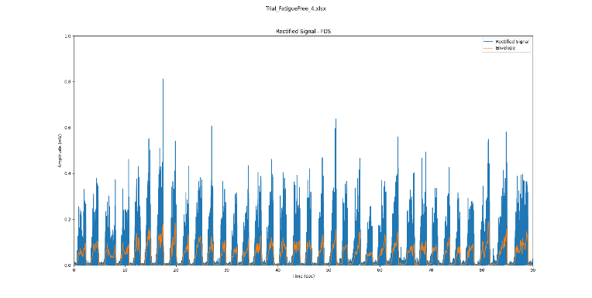
FDS Trial 4 Fatigue-Free – Rectified EMG Signal with EMG Envelope

[Figure 3]
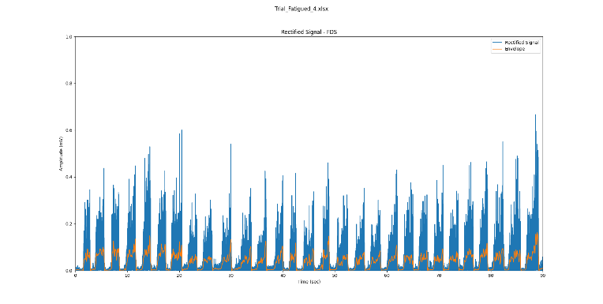
FDS Trial 4 Fatigued – Rectified EMG Signal with EMG Envelope

[Figure 4]
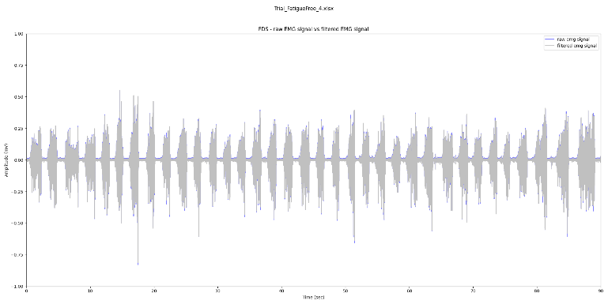
FDS Trial 4 Fatigue-Free - raw EMG signal with filtered EMG signal overlay

[Figure 5]
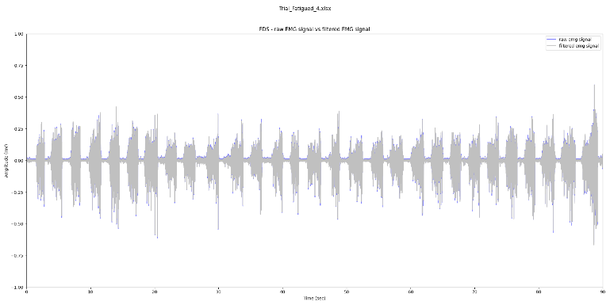
FDS Trial 4 Fatigued - raw EMG signal with filtered EMG signal overlay

Table 1. Time Domain Metrics of EDC
Time-Domain Metrics | MAV | RMS | SD
Trial 1 EDC FF | 0.030 | 0.047 | 0.047
Trial 1 EDC F | 0.030 | 0.047 | 0.047
Trial 2 EDC FF | 0.030 | 0.050 | 0.050
Trial 2 EDC F | 0.031 | 0.047 | 0.047
Trial 3 EDC FF | 0.028 | 0.046 | 0.046
Trial 3 EDC F | 0.031 | 0.045 | 0.045
Trial 4 EDC FF | 0.032 | 0.051 | 0.051
Trial 4 EDC F | 0.032 | 0.049 | 0.049
Trial 5 EDC FF | 0.037 | 0.056 | 0.056
Trial 5 EDC F | 0.032 | 0.049 | 0.049
*FF = Fatigue-Free, F = Fatigued, EDC = Extensor Digitorum Communis, FDS = Flexor Digitorum Superficialis

Table 2. Time-Domain Metrics of FDS
Time-Domain Metrics | MAV | RMS | SD
Trial 1 FDS FF | 0.029 | 0.048 | 0.048
Trial 1 FDS F | 0.032 | 0.055 | 0.055
Trial 2 FDS FF | 0.030 | 0.050 | 0.050
Trial 2 FDS F | 0.033 | 0.056 | 0.056
Trial 3 FDS FF | 0.029 | 0.050 | 0.050
Trial 3 FDS F | 0.033 | 0.059 | 0.059
Trial 4 FDS FF | 0.041 | 0.073 | 0.073
Trial 4 FDS F | 0.037 | 0.064 | 0.064
Trial 5 FDS FF | 0.047 | 0.083 | 0.083
Trial 5 FDS F | 0.039 | 0.071 | 0.071
*FF = Fatigue-Free, F = Fatigued, EDC = Extensor Digitorum Communis, FDS = Flexor Digitorum Superficialis

[Figure 6]
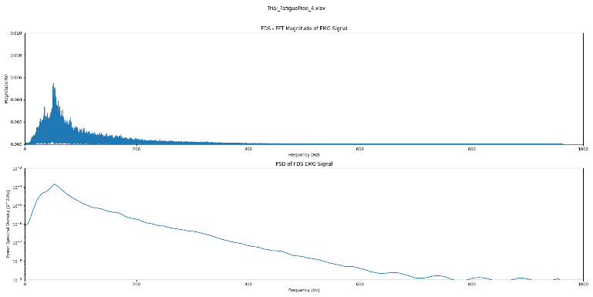
FDS Trial 4 Fatigue-Free – FFT and PSD

[Figure 7]
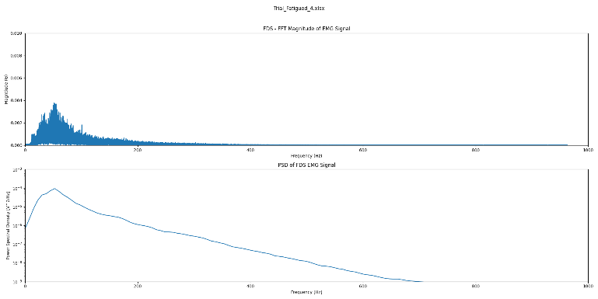
FDS Trial 4 Fatigued – FFT and PSD

[Figure 8]
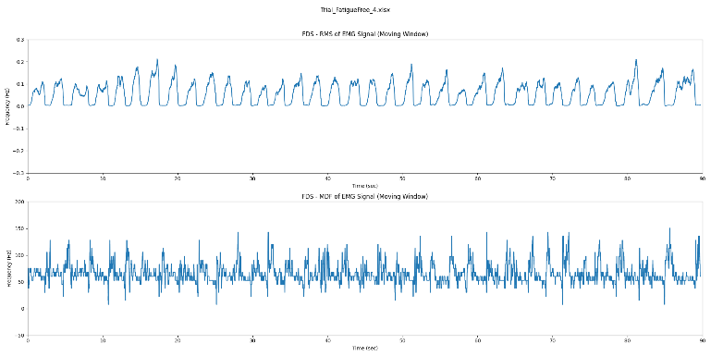
FDS Trial 4 Fatigue-Free – RMS and MDF

[Figure 9]
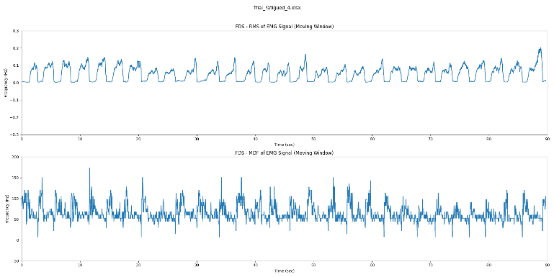
FDS Trial 4 Fatigued – RMS and MDF

DISCUSSION
These findings highlight the importance of frequency domain analysis in detecting muscle fatigue. The observed shifts in frequency components during fatigued conditions suggest that FFT could be a valuable tool for fatigue monitoring in AMSC environments. In these settings, where repetitive tasks are common, monitoring changes in muscle activity is crucial to prevent injuries and ensure productivity [1][2][20].
The less pronounced changes in time-domain metrics and PSD plots suggest that the preliminary data may not have been in a fully fatigued state, indicating the need for further investigation. Additionally, the lack of significant changes in the PSD plot might be due to compensatory mechanisms, where other muscles intervene to support fatigued ones, maintaining overall force [17].
The study results indicate that frequency domain analysis, particularly using FFT, can effectively monitor muscle fatigue by detecting shift in frequency components during fatigue [16]. In AMSC environments, where workers often perform repetitive tasks, this is often crucial [1][2][20]. By identifying the onset of muscle fatigue early, interventions can be implemented to prevent injuries, reduce downtime, and maintain high productivity levels [1][2][20].
Future research aims to validate these findings with a larger participant pool and more varied tasks. Integrating machine learning and deep learning models will help improve the accuracy and robustness of fatigue prediction. Additionally, exploring advanced signal processing and feature extraction techniques will further enhance the effectiveness of fatigue assessment protocols in AMSC environments. The goal is to continuously evaluate muscle fatigue in a non-intrusive matter that does not interfere with ongoing tasks, thereby enhancing worker safety and productivity in AMSC environments [1][2].

CONCLUSION
This study demonstrates the potential of using wearable EMG sensors and frequency domain analysis for monitoring muscle fatigue in AMSC environments. The initial findings suggest that FFT is a promising tool for fatigue detection, while time-domain metrics may be less sensitive in some cases. Future research will focus on validating these findings, refining the methodology, and integrating machine learning models to develop a comprehensive fatigue monitoring system.

Acknowledgment
This research was generously supported by the National Science Foundation under Grant No. 2244119. I am deeply grateful to Dr. Yunmei Liu for her invaluable guidance and support throughout this project. My heartfelt thanks extend to my team members, Moajjem Chowdhury, Yan Chen, Steven Martell, and Jessica Elliott, for their valuable feedback and assistance. I am also sincerely grateful to Dr. Faisal Aqlan for providing me with the opportunity to pursue this project.
I appreciate the support from the Department of Industrial Engineering at the University of Louisville for providing the necessary resources and facilities. Lastly, I want to express my deepest gratitude to my family for their unwavering support and encouragement throughout this research journey.
Please note that the opinions, findings, and conclusions expressed in this document are those of the author and do not necessarily reflect the views of the National Science Foundation.

References
[1] M. Moshawrab, M. Adda, A. Bouzouane, H. Ibrahim, and A. Raad, “Smart Wearables for the Detection of Occupational Physical Fatigue: A Literature Review,” Sensors, vol. 22, no. 19, p. 7472, Oct. 2022, doi: https://doi.org/10.3390/s22197472.
[2] N. R. Adão Martins, S. Annaheim, C. M. Spengler, and R. M. Rossi, “Fatigue Monitoring Through Wearables: A State-of-the-Art Review,” Frontiers in Physiology, vol. 12, Dec. 2021, doi: https://doi.org/10.3389/fphys.2021.790292.
[3] Johns Hopkins Medicine, “Electromyography (EMG),” Johns Hopkins Medicine, 2019. https://www.hopkinsmedicine.org/health/treatment-tests-and-therapies/electromyography-emg
[4] S.-H. Liu, C.-B. Lin, Y. Chen, W. Chen, T.-S. Huang, and C.-Y. Hsu, “An EMG Patch for the Real-Time Monitoring of Muscle-Fatigue Conditions During Exercise,” Sensors, vol. 19, no. 14, p. 3108, Jan. 2019, doi: https://doi.org/10.3390/s19143108.
[5] R. Chowdhury, M. Reaz, M. Ali, A. Bakar, K. Chellappan, and T. Chang, “Surface Electromyography Signal Processing and Classification Techniques,” Sensors, vol. 13, no. 9, pp. 12431–12466, Sep. 2013, doi: https://doi.org/10.3390/s130912431.
[6] “Flexor Digitorum Superficialis - Attachments - TeachMeAnatomy,” teachmeanatomy.info. https://teachmeanatomy.info/encyclopaedia/f/flexor-digitorum-superficialis/
[7] “Extensor Digitorum - Attachments - Actions - TeachMeAnatomy,” teachmeanatomy.info. https://teachmeanatomy.info/encyclopaedia/e/extensor-digitorum/
[8] L. Marotta et al., “Accelerometer-Based Identification of Fatigue in the Lower Limbs during Cyclical Physical Exercise: A Systematic Review,” Sensors, vol. 22, no. 8, p. 3008, Jan. 2022, doi: https://doi.org/10.3390/s22083008.
[9] K. G, “Trigno® Avanti Sensor,” Delsys. https://delsys.com/trigno-avanti/
[10] K. G, “Trigno Discover Software,” Delsys. https://delsys.com/trigno-discover/
[11] “Noise Purpose Hardware Concepts • The Surface EMG Signal • Delsys EMG Sensors • EMG Sensor Location and Placement • Experimental Set-up Software Concepts • Test Configuration Design • Data Acquisition • Refinement of Sensor Location.” Available: https://www.delsys.com/downloads/TECHNICALNOTE/101-emg-sensor-placement.pdf
[12]“EMG_SignalAnalysis/EMG_SignalAnalysis_Python.ipynb at master · redgene/EMG_SignalAnalysis,” GitHub. https://github.com/redgene/EMG_SignalAnalysis/blob/master/EMG_SignalAnalysis_Python.ipynb (accessed Jul. 02, 2024).
[13] ‌“EMG-Feature-Extraction-Toolbox/A_Main.m at master · JingweiToo/EMG-Feature-Extraction-Toolbox,” GitHub. https://github.com/JingweiToo/EMG-Feature-Extraction-Toolbox/blob/master/A_Main.m (accessed Jul. 02, 2024).
[14] J. Poppe, M. Hanks, and B. Slavens, Accessed: Jul. 31, 2024. [Online]. Available: https://bpb-us-w2.wpmucdn.com/sites.uwm.edu/dist/1/746/files/2020/04/Poppe_John.pdf
[15] J. R. Potvin and S. H. M. Brown, “Less is more: high pass filtering, to remove up to 99% of the surface EMG signal power, improves EMG-based biceps brachii muscle force estimates,” Journal of Electromyography and Kinesiology, vol. 14, no. 3, pp. 389–399, Jun. 2004, doi: https://doi.org/10.1016/j.jelekin.2003.10.005.
[16] M. V. Costa et al., “Fourier and wavelet spectral analysis of EMG signals in maximal constant load dynamic exercise,” Conference proceedings: ... Annual International Conference of the IEEE Engineering in Medicine and Biology Society. IEEE Engineering in Medicine and Biology Society. Annual Conference, vol. 2010, pp. 4622–4625, 2010, doi: https://doi.org/10.1109/IEMBS.2010.5626474.
[17] P. Kumar et al., “Spectral analysis of sEMG signals to investigate skeletal muscle fatigue,” Dec. 2011, doi: https://doi.org/10.1109/cdc.2011.6161297.
[18] H. A. Yousif et al., “Assessment of Muscles Fatigue Based on Surface EMG Signals Using Machine Learning and Statistical Approaches: A Review,” IOP Conference Series: Materials Science and Engineering, vol. 705, p. 012010, Dec. 2019, doi: https://doi.org/10.1088/1757-899x/705/1/012010.
[19]“emg/movingRMS.m at master · robbystk/emg,” GitHub. https://github.com/robbystk/emg/blob/master/movingRMS.m (accessed Jul. 31, 2024).
[20] “Ergonomics in the Modern Workplace: OSHA’s Guidance for Reducing Strain and Injury,” www.oshaeducationschool.com. https://www.oshaeducationschool.com/articles/ergonomics-in-the-modern-workplace-osha-s-guidance-for-reducing-strain-and-injury
[21] H. Jebelli and S. Lee, “Feasibility of Wearable Electromyography (EMG) to Assess Construction Workers’ Muscle Fatigue,” Advances in Informatics and Computing in Civil and Construction Engineering, pp. 181–187, Oct. 2018, doi: https://doi.org/10.1007/978-3-030-00220-6_22.
‌

‌

‌

